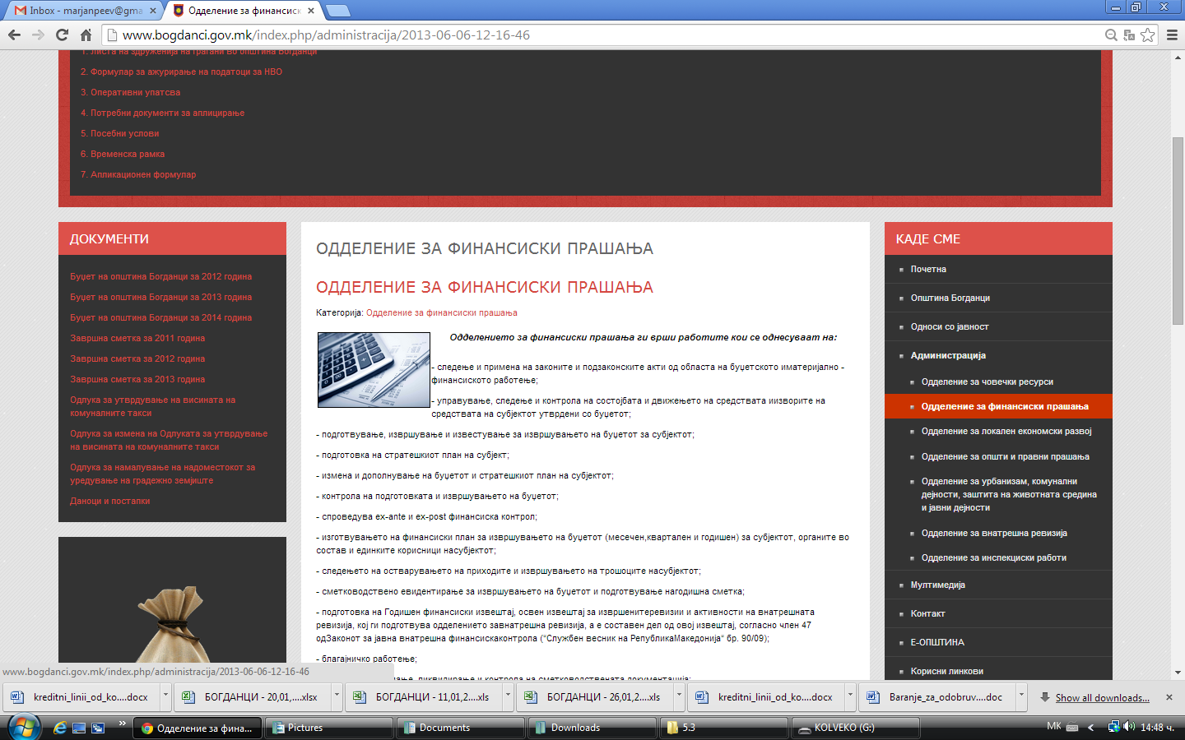

http://www.bogdanci.gov.mk/index.php/administracija/2013-06-06-12-16-46

